CONTRACT FOR EXHIBIT SPACE IN
VEGREVILLE AGRICULTURAL SOCIETY
MARKET PLACE

SHOW DATE: August 9-13, 2023
SET-UP: August 8, 1:00pm-8:00pm, August 9, 8:00am-11:00am
SHOW HOURS: Wed, Noon-8:00pm
Thurs, Noon-8:00pm
Fri, Noon-8:00pm
Sat, Noon-8:00pm
Sun, Noon-6:00pm
LOCATION: Vegreville Multi-Plex (4729-45 Ave)

CONTACT: Vegreville Ag Society Office 780-632-3950
@vegrevilleagsociety@gmail.com

Business Name:______________________________________________

Mailing Address:_____________________________________________
Street address or box #

_________________ __________________ ___________________
City Province Postal Code

Phone:______________________ Email:____________________________

Principle Contact:________________________________________________

List Brand Name and a Description of Product Sold. if exhibit is a service or information, list this. Only the items that have been listed may be displayed, demonstrated or sold. Exhibitors must contact the VAS with any changes or additions at least 24 hours prior to set up. The MarketPlace Committee will consider all such requests but does not guarantee authorization will be given.
____________________________________________________________________________

____________________________________________________________________________________________________________________________________________________________________________________________________________________________________

Table Size: 8’ x 30”
Layout Choices: Booth- 10’ x 10’ space, one table provided
Single Table- use of table only, no space
Cost: Booth (10’ x 10’) $250.00
Table (8’ x 30 ) $125.00
Additional Single Table (max of 2) $25.00

Chair provided per space
Power: power is only available in booths

Lease period: the lease commences at noon. Wednesday August 9, 2023, nd ends at 6:00pm Sunday August 13, 2023.
Exhibitors agree to keep displays intact until 6:00pm Aug 7/23
No exhibitor shall dismantle or remove their display prior to this set time.

Payment Terms: Full payment must be by July 8, 2023.

Payment Methods: cheque (payable to Vegreville Ag Society), Credit Card, Cash, E transfer @vegrevilleagsociety@gmail.com
Vegreville Ag Society, 4753- 45 Ave, Vegreville AB T9C 1L1

Booth _________ $250.00 ____________
Table ________ $125.00 ____________
(Additional) Single table space _________ $25.00(max 2) _______
Stamp Around ___________$40.00 ____________

GST ____________

Total Enclosed: _______________

Table # Preferred: _____________ (very effort will be made, however not guaranteed)
*Included with registration: 2 - 5-day gate bracelets
(Additional passes can be purchased thru VAS)

____ Thanks, but I do NOT require a table at my space.

OFFICE USE ONLY
Space #: _________________
Payment method: _________________
Date: ___________________
The Deerland Country Fair 2023
Stamp Around
Please, review the policies, sign and return with your contract and payment
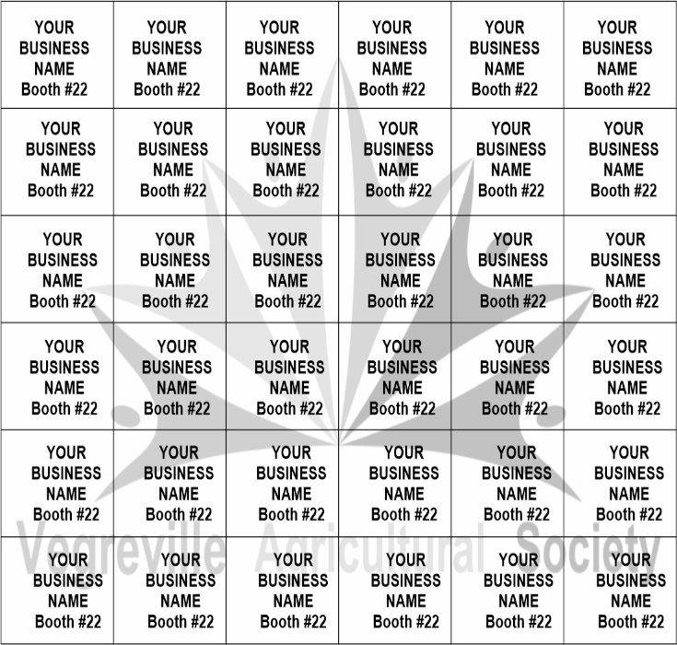
Your company name and booth number will be added to one square as shown in the sample to the left.
The public must go to all 36 participating booths and have the corresponding square stamped. You will need to provide you own stamp. This will be first come first serve bases with there be only 36 spots of a possible 55 vendors.
At the end of the show, there will be two draws. One person will receive $250.00, and the other will receive the basket of item received.

$40.00 or item of equal value
to participate
Please include payment with your contract

Exhibitor Company Name:

Contact Person: Contact Number:

Email: Booth #:

$40.00 Or Item
Circle one

2023 Exhibit Space - Terms & Conditions of Contract
- Vegreville Agricultural Soc, (VAS) agrees to provide exhibit space as described on page 2 of this contract.
- Exhibit space shall not be sublet by the Exhibitor without permission of the VAS.
- The VAS reserves the right to reject, prohibit or relocate exhibits for the good of the show.
- The VAS reserves the right to cancel this contract at any time.
- The Exhibitor is responsible for obtaining liability insurance for the period of the show, including move in/out. The Exhibitor is liable for any loss or damage caused by the exhibitor to others or the exhibition facility.
- No moving in or out of goods or dismantling of displays will be permitted during the entire run of the show. The Exhibitor agrees to remove his exhibit, etc. from the exhibit facility by the final move out time. If unable to do so, the Exhibitor agrees to make suitable arrangements or pay for such additional costs as may be incurred.
- The Exhibitor agrees to staff their table during show hours.
- The MarketPlace Manager may refuse entry to or require leaving (without refund) any visitor, exhibitor or person who, in the opinion of the MarketPlace Manager, is unfit, intoxicated or is in any way interfering with the smooth operation of the show, setup or dismantling thereof.
- Booth sharing is not allowed. Only one business if permitted per space.
- Display, demonstration, and distribution of promotional material outside the exhibitor’s space is not permitted.
- No Exhibitor will be allowed to move in until payment has been received in full.
- Cancellation Policy: up to 2 weeks prior- 75% refund will be issued 25% will be retained for administration costs, less than 2 week prior- no refund will be issued.
- All applicable municipal, provincial and federal regulations, including those pertaining to fire, health, safety and liquor must be complied with. The exhibitor assumes sole responsibility for the same.
- Exhibitors shall comply with all local and provincial ordinances covering licences, permits, etc. as required.
- Sound or audio/video equipment must be subdued sufficiently to not cause nuisance to other exhibitors.
- Height limitations~ applicable to single tables for displays: to a maximum of 2’ on the table, 4’ behind the table.
- We do not guarantee that alike business will not be in the same vicinity. An alike business may book a location, but not the same brands.

Liability/Insurance: the VAS shall not be responsible for loss or damage to displays or property of the exhibitor arising from any cause whatsoever, nor for any other claims or liabilities which may arise as a result of the granting of this agreement. The VAS shall not be responsible for personal injury caused to the exhibitor, his agents or employees while they are in the MarketPlace areas or arising from their participation in the MarketPlace. The exhibitor agrees to indemnify the VAS for any and all loss suffered by him or by any member of the public by reason of the negligence of the exhibitor, his agents or employees. Exhibitors are advised to contact their own insurer to arrange appropriate insurance coverage.

The undersigned acknowledges reading the contract and hereby agrees to abide by and be bound by the terms, conditions, rules and regulations contained in this document.

Exhibitor Name (please Print) _______________________________

Exhibitor Signature _________________________________

Date ___________________________

