__________________________________________________________________________

VEGREVILLE
OPEN HORSE SHOW
August 8-10, 2024
_______________________________________________________________________________________
Open to all levels of riders!
Last Day to Enter July 25, 2024
NO post/late entries will be accepted

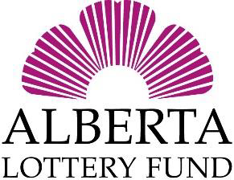
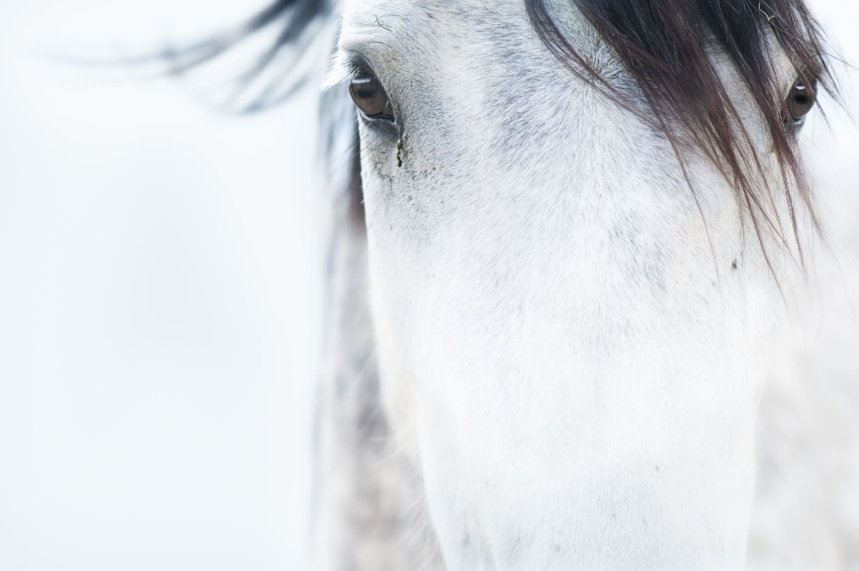
Welcome to Country Fair Horse Show

Show committee members:
Russell Crowe
Rhondalyn Twitchell
Kirby Lopaschuk
Rachel Farr
Daryl Cole
Bryan Maynard
Melissa Johnston

Please read the following Rules and Regulations.
The Society reserves the right to correct any error or make any alterations in the regulations or prize list. Classes may be rescheduled, canceled, or combined. If the class is cancelled entry fees will be refunded.
Any exhibitor making entries, by so doing, agrees to be governed by the Society’s rules and regulations.
All entries must be on printed forms supplied by the Society. In addition, the Vegreville Agricultural Society is NOT liable for ANY injuries caused by livestock.

Vegreville Agricultural Society
4753 45 Avenue
Vegreville AB T9C 1L1
Telephone: 780-632-3950 Toll Free: 1-888-611-0161
Email: vegrevilleagsociety@gmail.com www.vegag.ca
Questions about program classes and details text 780-603-9130
In all cases, the right is reserved to reject or accept any entry upon application.

Admission to Grounds
All persons entering the grounds, including exhibitors, are required to purchase gate admittance.
Daily admission: $5-12 and under $10, 13 and up
Camping Fees: $15/night no power and $25/night with power **if sleeping in trailer on grounds you must pay for camping**

Rules Governing Livestock Entries
1. Only animals from healthy herds are eligible for entry. Any exhibitor who knowingly enters an animal
from an unhealthy herd shall forfeit all prizes earned by him and will be excluded from exhibiting.
2. Abuse of animals will not be tolerated. Any person found abusing an animal will be excluded from
exhibiting and told to leave the fair grounds.
3. No animal exhibited shall be decorated with medals or prizes until after the awards are made in them
respective classes.
4. No animal will be left unattended if not securely tied in the barns or in their stalls. No tying to rails
5. The directors will take every precaution to ensure the safety of all animals, but will not hold
themselves responsible for the value thereof, or for any damage sustained to animals or property.
6. Exhibitors are responsible for making correct entries, NO REFUND for entry fee will be made for
classes incorrectly entered.

Rules Governing Judges and Judging
1. No person will be allowed to act as a judge who is in any way interested in the exhibits that person is to judge.
2. Any exhibitor lodging a protest must make it in writing, and it must be delivered to the Secretary within 48hrs after the close of the Country Fair, accompanied by a deposit of $75.00, which will be forfeited to the Society if the protest is not sustained.
3. It is the responsibility of the entrant to ensure that they are on time for their classes, once judging has commenced no one will be allowed in show ring. No refunds for exhibitors who miss their class. No person will be permitted in the animal show ring during the time of judging, except judges or assistants, persons in charge of animals, officers of the society, or members of the press.
4. Any exhibitor who makes a false entry, attempts to interfere with or influence a judge while in the discharge of their duties, or uses abusive or contemptuous language to a judge or show committee or personnel, shall forfeit his right to all prizes he might be entitled to and shall be excluded from exhibiting.
5. Judges shall, in all cases, withhold the awarding of prizes where the exhibit is not worthy, even though there may be no competition, or may award second or third prize where the exhibit does not come up to the proper standards.
6. The judge’s decision is final.
Regulations
3. A youth exhibitor is defined as not having reached their 18th birthday by January 1st, current year. No youth exhibitors are permitted to show stallions.
4. No cross-entering of Youth riders to Adult Performance Classes.
5. When the total number of entries in any class is four or less, the directors reserve the right to amalgamate the class with any other of the same type.
6. Breaks to be held at the discretion of the Show Committee.
7. This show will use the Rules and Regulations as set out in the AEF rule book as a guideline.
8. Ribbons will only be provided for Youth exhibitor classes and for Champion and Reserve Champion Halter classes.
9. Show attire required, long pants, full sleeve shirts, hat or helmets

Stabling
1. Stabling will be assigned on a first come, first serve basis.BUT Box stalls are limited, with priority given to horses staying for the three days.
3. Exhibitors are requested to see the stall posting list prior to taking possession of a stall.
4. Final stabling will be at the discretion of the committee. Due to unforeseen circumstances, the committee reserves the right to change stabling assignments.
5. There are no tack rooms available.
6. Stalls MUST be completely cleaned back to dirt floor to not be charge stall cleaning fee of $50.

Awards and Entry Fees

BOX STALLS: $20/day
BEDDING: $10 per shaving cube or 2 straw bales for $10
$50 per stall charge for stall cleaning, returnable if stall is cleaned.
Please WE WILL ONLY ACCEPT STALL CLEANING FEE AT THE SHOW OFFICE WHEN YOU PICK UP YOUR PACKAGE

ENTRY FEES $6 Youth/class, $8 Adult/class, $10 Open/class

NO POST ENTRIES ACCEPTED
AWARDS, YOUTH $15, $12, $10, $7, $5
AWARDS, ADULT $20, $15, $10, $8
AWARDS, OPEN $25, $20, $15, $10
JUNIOR STAKE ENTRY FEE $25
JUNIOR STAKE AWARD 40%, 30%, 20%, 10%
ADULT & OPEN STAKE ENTRY FEE $35
STAKE AWARD 40%, 30%, 20%, 10%
COSTUME AWARDS $40, $30, $20, $10, $5
FUN CLASSES AWARDS $13, $10, $8, $5, $3

**new this year**
YEARLING/ 2 YEAR OLD TRIFECTA $25 EXTRA TO ENTER
Yearling / 2 Year old horse who accumulates the most points from entering all 3 classes (halter, lungeline, inhand trail) will be awarded the Trifecta Challenge award. The Trifecta Challenge focuses on awarding a well rounded horse that is of excellent confirmation as well as movement and disposition. Classes are #57, #67 or #72, #73, #76 OR #77

TOP POINTS OF THE DAY AWARD (OVER ALL HORSE) – COMMITTEE WILL KEEP TRACK OF EVERY HORSE PLACING AT THE END OF THE 3RD DAY ANNOUNCE THE WINNERS.
Youth High Points Sponsor – Twitchell Family
Adult High Points Sponsor -

Youth are divided into the following groups:
Youth A under 7 years of age as of January 1, 2024
Youth B Exhibitors who have reached their 7th but not their 13th birthday as of January 1, 2024.
Youth C Exhibitors who have reached their 13th but not their 18th birthday as of January 1, 2024

Adults 18+ years old
Thursday, AUGUST 8, 2024
8:30 A.M.
No post entries accepted

CLASS 1 YOUTH A SHOWMANSHIP

CLASS 2 YOUTH B SHOWMANSHIP

CLASS 3 YOUTH C SHOWMANSHIP

CLASS 4 4H SHOWMANSHIP – Current 4H members – pattern – this class may be split into age groups

CLASS 5 YOUTH HALTER, MARE OR GELDING 13.2 HANDS AND UNDER

CLASS 6 YOUTH HALTER MARE OR GELDING OVER 13.2 HANDS

CLASS 7 YOUTH LEADLINE - 6 yrs. & under. Adult to lead. $5 PRIZE MONEY ALL AWARDED 1ST PLACE

**20 MINUTE BREAK **

ENGLISH TEST IN INDOOR ARENA
http://www.cadora.ca/display.asp?pageid=55

CLASS 8 OPEN DRESSAGE - Training Level Test A

CLASS 9 OPEN DRESSAGE – Training Level Test D

CLASS 10 OPEN DRESSAGE – First Level Test A

RESUME CLASSES IN MAIN SHOW RING

CLASS 11 YOUTH A ENGLISH PLEASURE

CLASS 12 YOUTH B ENGLISH PLEASURE

CLASS 13 YOUTH C ENGLISH PLEASURE

CLASS 14 YOUTH ENGLISH PLEASURE STAKE. Entry fee $25

CLASS 15 YOUTH A ENGLISH EQUITATION

CLASS 16 YOUTH B ENGLISH EQUITATION

CLASS 17 YOUTH C ENGLISH EQUITATION

CLASS 18 YOUTH ENGLISH EQUITATION STAKE Entry fee $25

CLASS 19 YOUTH 2 WAY VERSATILITY – ENGLISH (first) & WESTERN (second)

CLASS 20 YOUTH 4H EQUITATION English or Western

CLASS 21 YOUTH WALK TROT ENGLISH EQUITATION – no cross entries

CLASS 22 STICK HORSE - No entry fee. Ages 6 and under. To be judged on handling of the stick horse, appearance, and/or costume. Walk, trot, and gallop. Homemade horses preferred. $5 ALL FIRST PLACE

CLASS 23 YOUTH A WESTERN PLEASURE

CLASS 24 YOUTH B WESTERN PLEASURE

CLASS 25 YOUTH C WESTERN PLEASURE

CLASS 26 YOUTH WESTERN PLEASURE STAKE - Entry fee $25

CLASS 27 YOUTH A WESTERN EQUITATION

CLASS 28 YOUTH B WESTERN EQUITATION

CLASS 29 YOUTH C WESTERN EQUITATION

CLASS 30 YOUTH WESTERN EQUITATION STAKE – Entry fee $25

CLASS 31 YOUTH WALK TROT WESTERN EQUITATION – no cross entries

CLASS 32 YOUTH RANCH RIDING AQHA PATTERN 1

CLASS 33 YOUTH ON COMMAND

CLASS 34 YOUTH BAREBACK EQUITATION –equitation class judged while riding bareback

**Break 20 minutes**

CLASS 35 OPEN COSTUME - originality, cleverness, attractiveness and manner presented, horse and rider. Walking or riding permitted.

FRIDAY, AUGUST 8, 2024
8:30 A.M. START

*COMPULSORY TO WEAR A HARD HAT WITH AN ATTACHED CHIN STRAP WHEN JUMPING.

CLASS 36 YOUTH RIDER Maximum height 24” NO CROSS-ENTRY CLASS 47-52

CLASS 37 OPEN BEGINNER HORSE - POLES AND CAVALETTI - Maximum 24” height.
NO CROSS ENTRY OF HORSE INTO CLASSES 47-52

CLASS 38 OPEN HUNTER Maximum 2’3” height.

CLASS 39 OPEN HUNTER Max 2’6” height

CLASS 40 OPEN HUNTER Max 2’9” height

CLASS 41 OPEN JUMPER Max 2’6” height

CLASS 42 OPEN JUMPER Max 2’9” height

CLASS 43 OPEN GAMBLER’S CHOICE – Maximum 3’6” height (joker jump). 1 minute (60 secs). Max 2 x per jump

** HALF HOUR BREAK **

CLASS 44 OPEN HUNTER HACK – jump 24” Max

CLASS 45 OPEN SHOW HACK –To be shown at a walk, trot and canter both ways of the ring, collected and extended gates to be called for. To be judged on manners and performance

CLASS 46 ADULT ENGLISH PLEASURE JUNIOR HORSE – Horses 5 years old and under

CLASS 47 OPEN ENGLISH PLEASURE MAIDEN HORSE horses who have not placed 1st in an English Pleasure Class, as of January 1, 2024.

CLASS 48 ADULT ENGLISH PLEASURE WALK / TROT – No cross entries

CLASS 49 ADULT ENGLISH PLEASURE

CLASS 50 ADULT ENGLISH PLEASURE STAKE Entry fee $35

CLASS 51 ADULT ENGLISH EQUITATION

CLASS 52 ADULT ENGLISH EQUITATION WALK / TROT No cross entries

CLASS 53 ADULT ENGLISH EQUITATION STAKE – Entry fee $35

CLASS 54 ADULT ON COMMAND ENGLISH

CLASS 55 ADULT 2–WAY VERSATILITY STAKE – (English first, then Western) Entry fee $35

CLASS 56 OPEN PAIR’S RIDING - indicate both riders on entry form. prize to be split. Western or English. Late entries accepted. Quality and uniformity of performance 75%. Uniformity of horses and appointments 25%.

Saturday, AUGUST 10, 2024
NO POST ENTRIES ACCEPTED

WARM UP ARENA – 10:00 am – 3:30 PM EXHIBITORS CAN DO THEIR TRAIL & OBSTACLE CLASS ANYTIME

CLASS 57 OPEN IN HAND TRAIL YEARLINGS & 2 YEAR OLDS

CLASS 58 YOUTH A TRAIL

CLASS 59 YOUTH B TRAIL

CLASS 60 YOUTH C TRAIL

CLASS 61 OPEN TRAIL JUNIOR HORSE

CLASS 62 ADULT TRAIL

CLASS 63 OPEN TRAIL STAKE – Entry fee $35

CLASS 64 YOUTH RIDER OBSTACLE COURSE - timed

CLASS 65 OPEN OBSTACLE JUNIOR HORSE - timed

CLASS 66 ADULT OBSTACLE COURSE - timed

Saturday, AUGUST 10, 2024
8:30 A.M. MAIN SHOW RING
NO POST ENTRIES ACCEPTED

ADULT HALTER CLASSES

CLASS 67 STALLION - 1 year old and over.

CLASS 68 BROOD MARE AND FOAL - Judged 70% mare and 30% foal.

CLASS 69 FOAL - Calendar year.

CLASS 70 DRY MARE - 3 yrs and older

CLASS 71 GELDING - 3 yrs. and older

CLASS 72 FILLY OR GELDING – 2 years old

CLASS 73 YEARLING. Filly or gelding.

CLASS 74 OVERALL SHOW CHAMPION & RESERVE SHOW CHAMPION – (ALL 1st & 2nd placings from Halter classes)

CLASS 75 ADULT SHOWMANSHIP

CLASS 76 OPEN YEARLING LUNGELINE

CLASS 77 -OPEN 2 YR OLD LUNGELINE

**BREAK 45 MINS**

WESTERN DRESSAGE TESTS IN INDOOR ARENA
http://www.westerndressageassociation.org/western-dressage-rules-tests/

CLASS 78 OPEN WESTERN DRESSAGE – Intro level test 1

CLASS 79 OPEN WESTERN DRESSAGE – Basic Level 3

RESUME CLASSES IN MAIN SHOW RING

CLASS 80 ADULT WESTERN PLEASURE JUNIOR HORSE - Horses 5 years old and under.

CLASS 81 OPEN WESTERN PLEASURE MAIDEN HORSE - Horses that have not placed 1st in a Western
Pleasure Class, as of January 1, 2024

CLASS 82 ADULT WESTERN PLEASURE WALK / TROT – NO CROSS ENTRIES

CLASS 83 ADULT WESTERN PLEASURE

CLASS 84 ADULT WESTERN PLEASURE STAKE –Entry fee $35

CLASS 85 SENIORS IN THE SADDLE - Riders 55 years old and holding.

CLASS 86 ADULT WESTERN EQUITATION

CLASS 87 ADULT WESTERN EQUITATION WALK/TROT No cross entries

CLASS 88 ADULT WESTERN EQUITATION STAKE – Entry fee $35

CLASS 89 ADULT ON COMMAND WESTERN

CLASS 90 OPEN WESTERN RIDING AQHA PATTERN 8

CLASS 91 OPEN REINING – AQHA REINING PATTERN A

CLASS 92 OPEN RANCH RIDING RAIL CLASS

CLASS 93 ADULT RANCH RIDING – AQHA RANCH RIDING PATTERN 10

CLASS 94 OPEN PATTERN TO MUSIC - English, western or driving. Maximum length 4 minutes. Costumes are preferred but not required. Props are permitted but at no time may hinder the
judge’s view of the horse. UP TO 5 HORSES

FUN CLASSES
NO POST ENTRIES ACCEPTED

CLASS 95 YOUTH BARREL RACING

CLASS 96 ADULT BARREL RACING

CLASS 97 YOUTH POLE BENDING

CLASS 98 ADULT POLE BENDING

CLASS 99 OPEN MUSICAL CHAIRS

CLASS 100 OPEN SACK RACE – Rider are mounted on one end of arena – race to other end – hop off and grab a sack – with horse in tow potato sack race (hop) to the other end of the arena.

CLASS 101 OPEN PONY EXPRESS – Ride to end of arena, pick up mail, ride back to start drop mail in bin cross finish line. Timed event

CLASS 102 OPEN BAREBACK $5 BILL - Winner takes all. Bring your own $5 bill.

