**Vegreville Yardscapes Handbook**

**Nomination Details:**

* Nominations will open June 16th, 2025 and close at midnight of July 18th, 2025. Judging will be held between July 21st and August 1st; dates and times to be determined.

**Eligibility**

* Will have to be a resident and/or business owner of the Vegreville, AB.

**How to Enter**

All entries are required to be completed in full and received prior to Midnight July 18th, 2025.

There are 3 options:

* **Email:**

Vegrevillegardenclub@gmail.com

* I**n Person:**

Drop off Nomination form at Vegreville Agricultural Society Office

4753 45 Ave, Vegreville, AB

* **By Mail:**

Vegreville Agricultural Society Office 4753 45 Ave, Vegreville, AB T9C 0B2

**Class categories**  
There are 4 categories for the 2025 year.

* Best front yard
* Best Balcony
* Best Business
* Community Choice Award

**Prizes**

* Winners in each of the Category will receive a Garden sign in recognition, and - of course - neighborhood bragging rights, value - priceless!
* To be awarded after August 11th.

**Judging Criteria**

* Yards will be judged on areas of aesthetics, plant variety and condition, neatness, and unique features. Judging will take place during July 21st and August 1st; dates and times to be determined. You will be informed a couple days prior. Judging criteria is listed below.

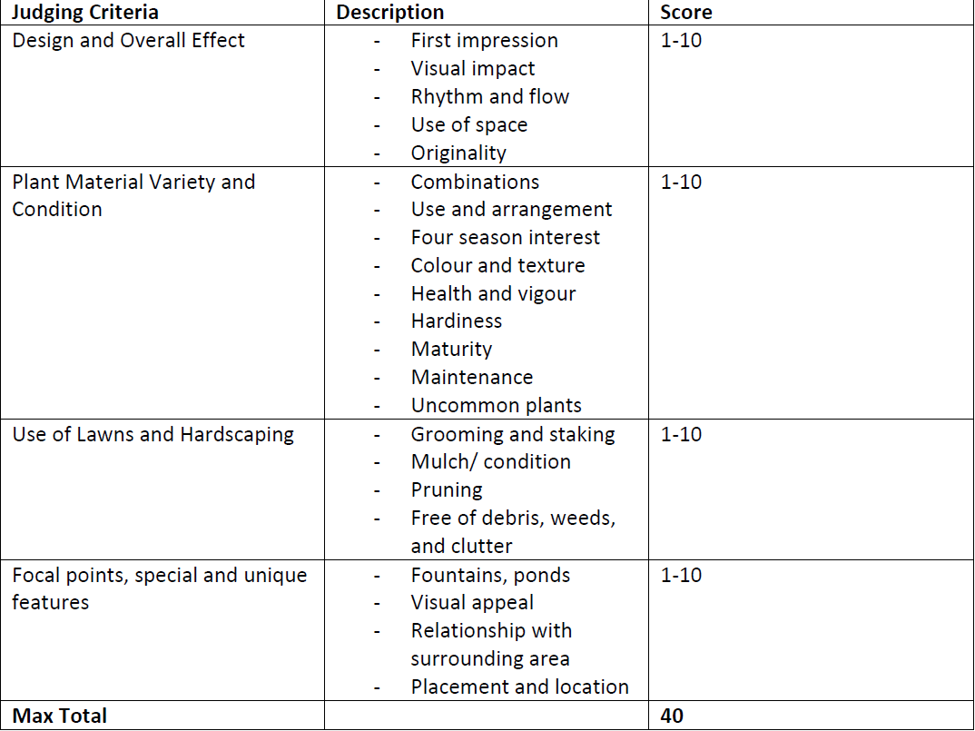

* The voting criteria used by the judges will be the following. Each criteria item will be scored on a scale of 1-10 with 10 being the best.
* Community Choice award will be determined by ballet vote by Fair attendees during the 2025 Vegreville County Fair.

**Entry rules:**

* Nomination forms are required to be completed in full for consideration.
* Nominations will open Jun 16th, and entries must be received by midnight on July 18th.
* All nominees will receive a “Nomination” sign to be displayed on their front yard/balcony throughout the summer.
* Nominees will return Nomination sign at the end of the summer.
* Entry forms can be filled out online or downloaded and emailed to [vegrevillegardenclub@gmail.com](mailto:vegrevillegardenclub@gmail.com) or submitted in person at the Vegreville Agricultural society building or mailed. (Mailed submissions are required to be received by Midnight July 18th).
* Contest is open to residents of Vegreville only. For the 2025 year, Residents of surrounding Counties are not eligible for nomination.
* Judging will take place between July 21st and August 1st. Entrants will be notified a few days prior of their judging time.
* Entrants who are deemed to have interfered with the judging in anyway can be disqualified.
* Any garden found to have prohibited noxious or uncontrolled noxious weeds will be disqualified. For details on plants considered as Noxious weeds in Alberta see [Provincially regulated weeds | Alberta.ca](https://www.alberta.ca/provincially-regulated-weeds)
* The decision of the judges is final.
* Photographs of all entries will be taken for presentation and promotional purposes.
* By entering the contest, entrants give permission for photos to be taken.

**Category Specific Rules:**

* **Front Yard**
  + Front gardens ONLY will be judged, with as much of the side garden as is visible from the street.
  + Yard to be free of noxious weeds as identified by the Government of Alberta
* **Balcony:**
  + This Category is open to those who do not have a front yard or live in a multi-family living complex where the balcony would be considered their yard.
* **Business:** 
  + Business fronts where customers would enter will ONLY will be judged.
* **Community Choice Award:**
  + the top 5 entries determined by the judging panel will be showcased at the Vegreville County Fair where community members can vote for the winner.

**Tips for entrants on judging days**

* Depending on the number of entries, judging will take place between July 21st and August 1st, weather permitting.
* You will be told the date that the judging will take place a couple of days in advance, that way you can be prepared.
* Ensure that your garden is accessible. Make sure your garden is ready for judging on the days you have been told.
* Turn off sprinklers.
* Restrain pets.
* Judging will happen rain or shine but will be postponed due to any thunderstorms or extreme weather.